Name Removed

Homework 1

P2.2

1. 3-digit numbers possible = 10\*10\*10 = 1000
2. Numbers (possible) beginning with digit 1 = 1\*10\*10 = 100
3. Numbers (possible) ending with digit 9 = 10\*10\*1 = 100
4. Numbers (possible) beginning with digit 2 & ending with digit 9 = 1\*10\*1 = 10
5. Probability of number ending with 9 given it begins with 2:

P(A|B) = P(A and B)/P(B) for independent A & B

P(begin with 2) = 100/1000 = 1/10

P(end with 9) = 100/1000 = 1/10

P(begin with 2 and end with 9) = P(begin with 2) \* P(begin with 9) = 1/10 \* 1/10 = 1/100

P(ending with 9|beginning with 2) = (1/100)/(1/10) = 10/100 = 1/10 = .1

P2.3

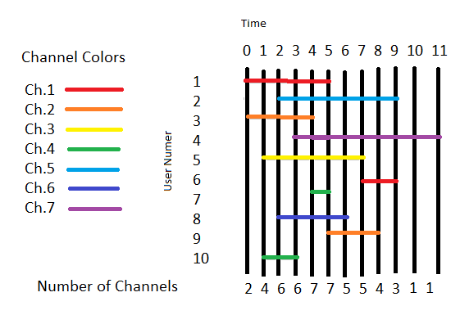

1. Average = sum/count = 42/10 = 4.2 units
2. Minimum Number of channels required = 7
3. Allocation of channels:
   1. Time 0
      1. Channel 1 = User 1
      2. Channel 2 = User 3
      3. Channel 3 = Free
      4. Channel 4 = Free
      5. Channel 5 = Free
      6. Channel 6 = Free
      7. Channel 7 = Free
   2. Time 1
      1. Channel 1 = User 1
      2. Channel 2 = User 3
      3. Channel 3 = User 5
      4. Channel 4 = User 10
      5. Channel 5 = Free
      6. Channel 6 = Free
      7. Channel 7 = Free
   3. Time 2
      1. Channel 1 = User 1
      2. Channel 2 = User 3
      3. Channel 3 = User 5
      4. Channel 4 = User 10
      5. Channel 5 = User 2
      6. Channel 6 = User 8
      7. Channel 7 = Free
   4. Time 3
      1. Channel 1 = User 1
      2. Channel 2 = User 3
      3. Channel 3 = User 5
      4. Channel 4 = User 10
      5. Channel 5 = User 2
      6. Channel 6 = User 8
      7. Channel 7 = User 4
   5. Time 4
      1. Channel 1 = User 1
      2. Channel 2 = User 3
      3. Channel 3 = User 5
      4. Channel 4 = User 7
      5. Channel 5 = User 2
      6. Channel 6 = User 8
      7. Channel 7 = User 4
   6. Time 5
      1. Channel 1 = User 1
      2. Channel 2 = User 9
      3. Channel 3 = User 5
      4. Channel 4 = User 7
      5. Channel 5 = User 2
      6. Channel 6 = User 8
      7. Channel 7 = User 4
   7. Time 6
      1. Channel 1 = Free
      2. Channel 2 = User 9
      3. Channel 3 = User 5
      4. Channel 4 = Free
      5. Channel 5 = User 2
      6. Channel 6 = User 8
      7. Channel 7 = User 4
   8. Time 7
      1. Channel 1 = User 6
      2. Channel 2 = User 9
      3. Channel 3 = User 5
      4. Channel 4 = Free
      5. Channel 5 = User 2
      6. Channel 6 = Free
      7. Channel 7 = User 4
   9. Time 8
      1. Channel 1 = User 6
      2. Channel 2 = User 9
      3. Channel 3 = Free
      4. Channel 4 = Free
      5. Channel 5 = User 2
      6. Channel 6 = Free
      7. Channel 7 = User 4
   10. Time 9
       1. Channel 1 = User 6
       2. Channel 2 = Free
       3. Channel 3 = Free
       4. Channel 4 = Free
       5. Channel 5 = User 2
       6. Channel 6 = Free
       7. Channel 7 = User 4
   11. Time 10
       1. Channel 1 = Free
       2. Channel 2 = Free
       3. Channel 3 = Free
       4. Channel 4 = Free
       5. Channel 5 = Free
       6. Channel 6 = Free
       7. Channel 7 = User 4
   12. Time 11
       1. Channel 1 = Free
       2. Channel 2 = Free
       3. Channel 3 = Free
       4. Channel 4 = Free
       5. Channel 5 = Free
       6. Channel 6 = Free
       7. Channel 7 = User 4
4. Total times = 12 (0-11)
   1. Channel 1 = 9/12
   2. Channel 2 = 9/12
   3. Channel 3 = 7/12
   4. Channel 4 = 5/12
   5. Channel 5 = 8/12
   6. Channel 6 = 5/12
   7. Channel 7 = 9/12

P2.4

P(CDMA) = 0.4

P(All CDMA) = Binomial distribution with 3 successes, 3 trials, and 0.4 probability of success

= (3 choose 3) \* 0.4^3 \* 0.6^(3-3)

= (3!/3!(0!)) \* 0.4^3 \* 1

= 1 \* 0.4^3

= 0.4^3

= 0.064